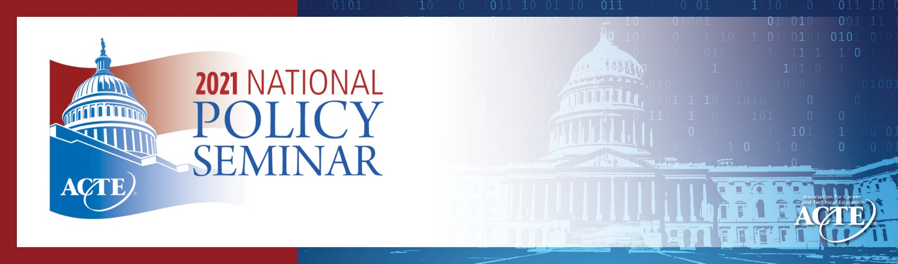
SAMPLE
THANK YOU #3

IMPORTANT NOTE: Send a letter like this to any congressional staff person that attended your meeting.

Dear _________________,

I would like to express my appreciation for the opportunity to meet with you virtually during CTE Month and as a part of the Association for Career and Technical Education’s (ACTE) 2021 National Policy Seminar.

You will recall that we touched on [list the key issues that you discussed, e.g. funding for CTE programs, effects of COVID-19 on education and workforce, or other issues].

[You can include some talking points if you wish, drawing on ACTE’s background materials documents.]

[If you promised to follow up with any other information, include it here.]

I look forward to continuing this relationship and to future meetings. In the meantime, if I can be of any assistance, please do not hesitate to contact me or Michael Matthews (mmatthews@acteonline.org), the Government Relations Manager for ACTE.

Sincerely,

[Your name, school, and location]

