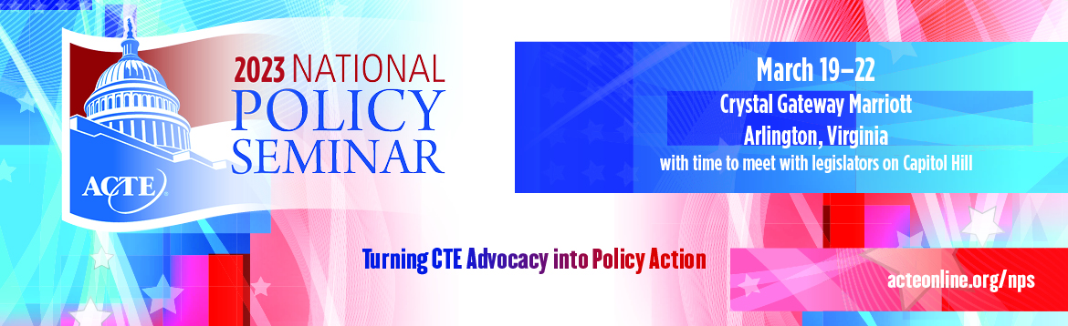

SAMPLE THANK YOU #3
IMPORTANT NOTE: Send a letter like this to any congressional staff person that attended your meeting.

Dear _________________,

I would like to express my appreciation for the opportunity to meet with you during the Association for Career and Technical Education’s (ACTE) 2023 National Policy Seminar.

You will recall that we touched on [list the key issues that you discussed, e.g., funding for CTE programs, workforce issues, etc.].

[You can include some talking points if you wish, drawing on ACTE’s background materials documents.]

[If you promised to follow up with any other information, include it here.]

I look forward to continuing this relationship and to future meetings. In the meantime, if I can be of any assistance, please do not hesitate to contact me or Alisha Hyslop (ahyslop@acteonline.org), the Senior Director of Public Policy at ACTE.

Sincerely,

[Your name, school, and location]

