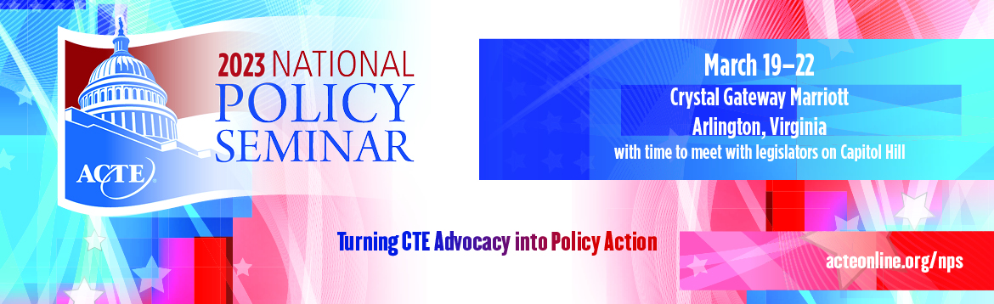

SAMPLE THANK YOU #2
IMPORTANT NOTE: Send a letter like this to your Members of Congress when they were not available and you met only with staff. Be sure to send a separate note directly to the staff member as well.
The Honorable (Representative’s name)
U.S. House of Representatives
Washington, DC 20515
OR
The Honorable (Senator’s name)
United States Senate
Washington, DC 20510
Dear Senator/Representative _________________,
I would like to express my appreciation for the opportunity to meet with [Insert staffer’s name] during the Association for Career and Technical Education’s (ACTE) 202 National Policy Seminar. I know your staff is very busy, and I was pleased that we were able to take the time to meet and discuss issues that are important to the CTE community.
[Staffer’s Name] and I had a productive conversation about [list the key issues that you discussed, e.g. funding for CTE programs, workforce issues, etc.].
[You can include some talking points if you wish, drawing on ACTE’s background materials documents.]
I look forward to continuing this relationship and to future meetings with both you and your dedicated staff. In the meantime, if I can be of any assistance, please do not hesitate to contact me or Alisha Hyslop (ahyslop@acteonline.org), the Senior Director of Public Policy at ACTE.
Sincerely,
[Your name, school, and location]

