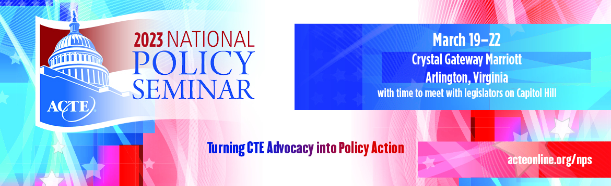

SAMPLE THANK YOU #1
IMPORTANT NOTE: Send a letter like this to your Member of Congress if you met with them directly. Be sure to send a separate note to any staff who participated in the meeting.

The Honorable (Representative’s name)
U.S. House of Representatives
Washington, DC 20515

OR

The Honorable (Senator’s name)
United States Senate
Washington, DC 20510

Dear Senator/Representative _________________,

I would like to express my appreciation for the opportunity to meet with you as part of the Association for Career and Technical Education’s (ACTE) 2023 National Policy Seminar. I know you are very busy, and I am grateful that you made time to talk with me about issues that are important to the CTE community.

You will recall that we touched on [list the key issues that you discussed, e.g. funding for CTE programs, workforce issues, etc.].

[You can include some talking points if you wish, drawing on ACTE’s background materials documents.]

[If you promised to follow up with any other information, include it here.]

I look forward to continuing this relationship and to future meetings with both you and your dedicated staff. In the meantime, if I can be of any assistance, please do not hesitate to contact me or Alisha Hyslop (ahyslop@acteonline.org), the Senior Director of Public Policy at ACTE.

Sincerely,

[Your name, school, and location]

